Title of the paper (Spanish) (Garamond 14, bold, justified)
Title of the paper (English) (Garamond 14, bold, justified)

NAME FAMILY NAME (GARAMOND 12)
Organism or Institution, e-mail (Garamond 10)

Abstract
Abstract not exceeding 150 words (Spanish) (Garamond 12, justified).

Abstract not exceeding 150 words (English) (Garamond 12, justified).

Keywords
Please indicate between 3 and 5 keywords, separated by commas (Spanish) (Garamond 10, justified)
Please indicate between 3 and 5 keywords, separated by commas (English) (Garamond 10, justified)

Topic
Papers will adhere to one of the four proposed topics, please indicate it here (Garamond 10, justified)

Introduction (Garamond 12, bold, justified)
Authors invited by the Organising Committee to present a full paper may write it either in Spanish or in English. Full papers must be submitted through the online platform. Files should be saved either as .doc or .docx file, not exceeding 20 MB, and named according to the following code: Topic number_Family Name_Name_paper. For example: 1_García_Carmen_paper.
Deadline for the reception of full papers: Friday, October 30th, 2020.
Submission of the full paper implies that this work is previously unpublished, and that the content and images included are not subject to copyright. In order to assure that, authors will accept the Declaration of authorship, good practices and transfer of rights in the submission platform.
Particular care should be taken to cite sources and any works by other authors; all citations must be duly checked by the author, and placed in the text according to this style guide.

Text format
Papers will respect the layout presented in this template as well as the style indications specified in this style guide. Failure to comply with these instructions will result in the rejection of the communication and its subsequent exclusion from the Conference Proceedings. Therefore, it is strongly recommended to overwrite this document instead of formatting a new file.
The Organising Committee reserves the right to make the necessary editorial changes to the texts presented.

Text length
Texts should be of no fewer than 3,000 words and no more than 4,000 words, including footnotes but not image captions.

Text structure
Texts will be produced using the Garamond 12 font, with justified alignment.
If necessary, texts may be organized into different paragraphs (three levels maximum). Headings will not be numbered and will follow this format:
First level heading (Garamond 12, bold, justified)
Second level heading (Garamond 12, bold, italic, justified)
Third level heading (Garamond 12, underlined, justified)
Within the text no indent will be used and no space between paragraphs will be introduced. A single space will be placed only before a new headline (in any level).

Images and captions
Texts may be accompanied by a maximum of 7 figures. Any picture, illustration, table, map, diagram, etc. will have enough quality to be correctly visualized (in both printed and digital formats), considering not to overpass the 20 MB limit for the whole Word file. Images must be copyright-free, if not, authors are responsible for obtaining any permission needed for their publication. The Organising Committee will be exempt from any responsibility in that matter.
All figures will be mentioned throughout the text, in parentheses (fig. 1), with the corresponding number, starting the numbering from 1. The figures will be inserted in the document in the order in which they are outlined in the text, occupying an immediate position to where they are mentioned and ensuring that their insertion does not interrupt a paragraph.
All figures will be inserted centred on the page and will be no more than 16 cm wide. The caption of each image will include, at least, the following data: number of the figure, author (Name Family Name), title, and source.
The Organising Committee reserves the right to eliminate any figure whose quality and/or identification is considered insufficient.

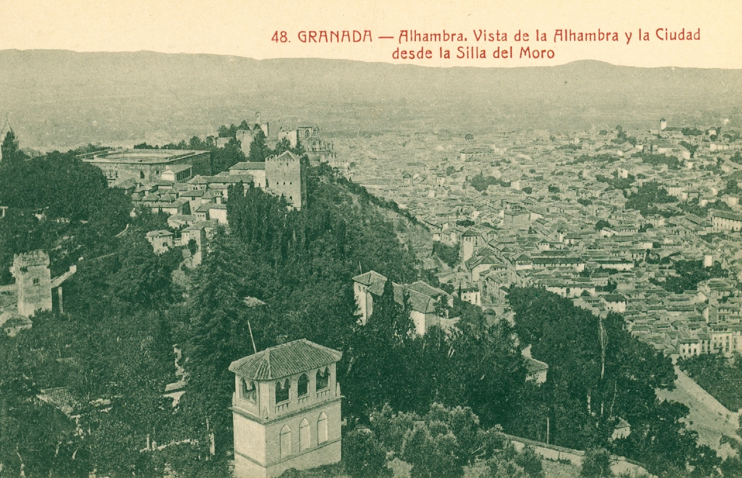

Figure 1: Abelardo Linares, Alhambra. Vista de la Alhambra y la Ciudad desde la Silla del Moro (Granada nº 48), 1890 ca. (Archivo Municipal de Granada) (Garamond 10, justified).

Footnotes and bibliographic references
Any note that the author considers necessary to include will go to the end of the corresponding page. In the text they will be indicated in superscript, just behind the word or phrase to be referenced, as it appears in this document.
In any case, the text will not include a final bibliography heading, so any bibliographic source or reference must be indicated in the footnotes. References will conform to the notes and bibliography system of The Chicago Manual of Style (17th ed.).

Quotes
Every text quotation must be enclosed in quotation marks (“ ”) and include a footnote indicating its origin in accordance with the notes and bibliography system of The Chicago Manual of Style (17th ed.).
Any bibliographic reference mentioned in the text will also require its corresponding footnote. This note will indicate all the reference data according to The Chicago Manual of Style (17th ed.).
Remember that the text should not include a specific bibliography heading.

Footnote (Garamond 10, justified).
Guidelines to correctly cite the most common references can be found in the style guide document, to be downloaded from the website: “Chicago Manual_examples”.
We refer to the previous note.
We refer to the note 2.

